Mockup 1 for the Maze Game

Symbol and Description:
- The Plyer:

- Moving Enemy:

- Punishment:

- Required Reward:

- Optional Reward:

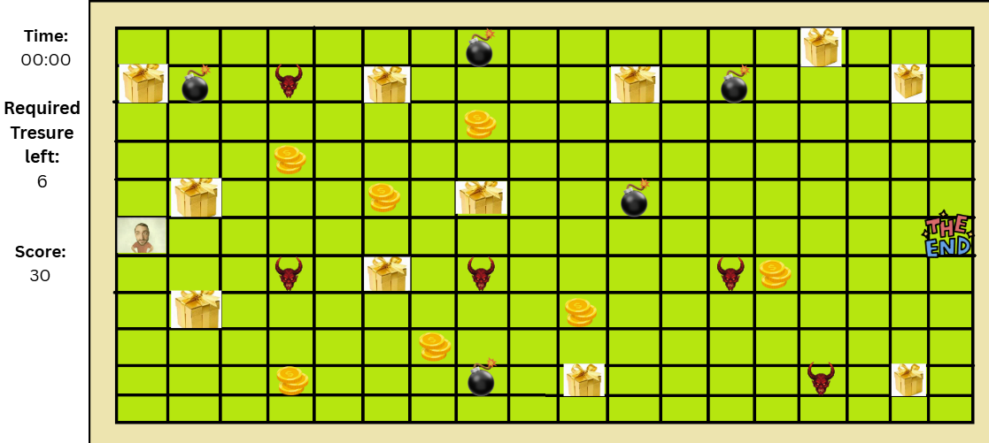
Mockup2 for the Maze Game

Symbol and Description:
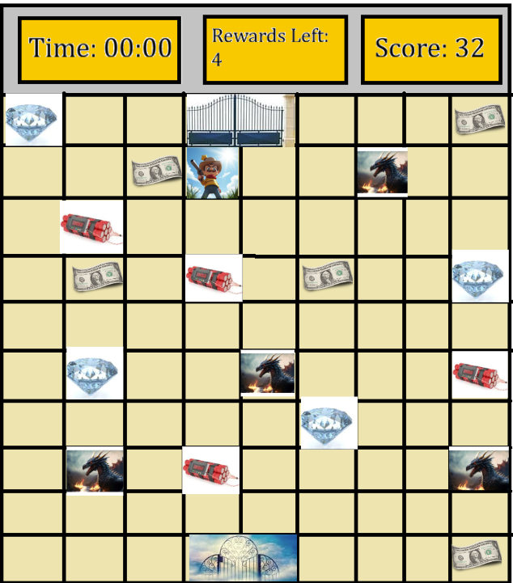
- The Player:

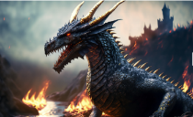
- Moving Enemy:

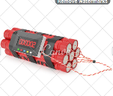
- Punishment:

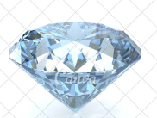
- Required Rewards:


- Optional Rewards:

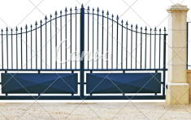
- Start Place:


- The End Gate:

